Consider a *counterflow*, *annular* heat exchanger with a cold fluid in the inside tube and a hot fluid in the annular space. To improve heat transfer, struts with a fin efficiency, ηf = 0.273, and a thickness of 0.003 m connect the outside surface of the inside tube to the outer wall. Using the properties below, calculate the exiting temperature of the hot fluid. Conduction through the outer wall is negligible.

|  |  |  |  |  |  |  |
| --- | --- | --- | --- | --- | --- | --- |
| **Pipe properties** | OD of outer tube (m) | OD of inner tube (m) | ID of inner tube (m) | Length of pipe (m) | k (W/m-K) | t(m) |
|  | 0.4 | 0.2 | 0.1 | 5 | 50 | 0.003 |
|  |  |  |  |  |  |  |
| **Cold fluid properties** | Pr | Viscosity  (N-s/m2) | k (W/m-K) | Mass flow rate (kg/s) | Heat capacity | Tin (oC)  Tout(oC) |
|  | 5.83 | 8.55 X 10-4 | 0.631 | 1 | 400 J/kg-oC | 15  75 |
|  |  |  |  |  |  |  |
| **Hot fluid** | m (kg/s) | Cp | Conv Coef., ho |  |  |  |
|  | 3 | 400 J/kg-oC | 100 W/m2-K |  |  |  |

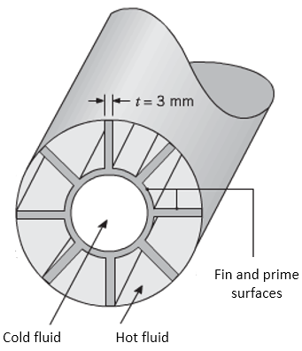

Th,o = 117.2 oC